GEOMETRY POSTULATES, PROPERTIES AND THEOREMS

Postulate 1-1

Postulate 1-2

Postulate 1-3

Postulate 1-4

Postulate 1-5
Ruler Postulate

Definition of Congruent Segments

Postulate 1-6
Segment Addition
Postulate
Definition of Midpoint

Definition of Perpendicular Lines

Definition of Perpendicular Bisector

Postulate 1-7  Protractor Postulate | 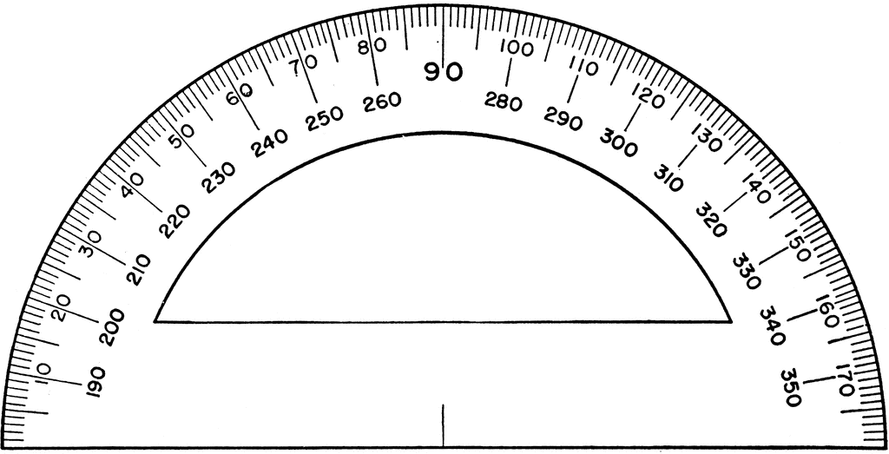
Postulate 1-8
Angle Addition Postulate

Definition of Congruent Angles

Definition of Angle Bisector

Distance Formula
Midpoint Formula
Perimeter and Area of a Square
Perimeter and Area of a Rectangle
Circumference and Area of a Circle
Postulate 1-9

Postulate 1-10

Definition of a Conditional

Venn Diagram
Definition of a Converse
Definition of a Biconditional

Negation of Statements

Definition of an Inverse
Definition of a Contrapositive
Equivalent Statements
Writing an Indirect Proof | 1. Assume the opposite (negation) of what you want to prove.  2. Show that this assumption leads to a contradiction.  3. Conclude that Therefore, the assumption must be false and that what you want to prove must be true.

Law of Detachment
Law of Syllogism
Addition Property of Equality
Subtraction Property of Equality

Multiplication Property of Equality

Division Property of Equality

Reflexive Property of Equality

Symmetric Property of Equality

Transitive Property of Equality

Substitution Property

Distributive Property of Equality

Reflexive Property of Congruence

Symmetric Property of Congruence

Transitive Property of Congruence

Definition of Adjacent Angles

Definition of Vertical Angles

Theorem 2-1
Vertical Angles Theorem

Definition of Supplementary

Definition of Complementary

Theorem 2-2
Congruent Supplements Theorem

Theorem 2-3
Congruent Complements Theorem

Theorem 2-4
Theorem 2-5

Postulate 3-1
Corresponding Angles Postulate

Theorem 3-1
Alternate Interior Angles Theorem

Theorem 3-2
Same-Side Interior Angles Theorem

Postulate 3-2
Converse of the Corresponding Angles Postulate

Theorem 3-3
Converse of the Alternate Interior Angles Theorem

Theorem 3-4
Converse of the Same-Side Interior Angles Theorem
Theorem 3-5

Theorem 3-6

Theorem 3-7
Triangle Sum Theorem

Theorem 3-8
Triangle Exterior Angle Theorem

Classifying Triangles
By Sides
Classifying Triangles
By Angles

Theorem 3-9
Polygon Angle Sum Theorem

Each Interior Angle of a REGULAR Polygon
Theorem 3-10
Polygon Exterior Angle Sum Theorem

Each Exterior Angle of a REGULAR Polygon
Slope-Intercept Form of a Line

Standard Form of a Line

Point-Slope Form of a Line

Summary
Horizontal Lines

Summary
Vertical Lines

Summary
Slopes of Parallel Lines

Summary
Slopes of Perpendicular Lines

Theorem 4-1
Congruent Angles of Triangles

Postulate 4-1
Side-Side-Side Postulate
(SSS)

Postulate 4-2
Side-Angle-Side Postulate
(SAS)

Postulate 4-3
Angle-Side-Angle Postulate
(ASA)

Theorem 4-2
Angle-Angle-Side Theorem
(AAS)

Congruent Triangles →
Congruent Parts
CPCTC

Theorem 4-3
Isosceles Triangle Theorem

Corollary to Theorem 4-3
Equilateral →
Equiangular

Theorem 4-4
Converse of Isosceles Triangle Theorem

Corollary to Theorem 4-4
Equiangular →
Equilateral

Theorem 4-5
Isosceles Triangle Bisector Theorem

Theorem 4-6
Hypotenuse-Leg
Theorem
(HL)

Theorem 5-1
Triangle
Mid-segment Theorem

Theorem 5-2
Perpendicular Bisector Theorem

Theorem 5-3
Converse of the Perpendicular Bisector Theorem

Theorem 5-4
Angle Bisector Theorem

Theorem 5-5
Converse of the Angle Bisector Theorem

Theorem 5-6

Circumcenter

Theorem 5-7

Incenter

Theorem 5-8

Centroid

Theorem 5-9

Orthocenter

Comparison Property of Inequality

Corollary to the Triangle Exterior Angle Theorem

Theorem 5-10

Theorem 5-11

Theorem 5-12
Triangle Inequality Theorem

Definition of a Parallelogram

Definition of a Rhombus

Definition of a
Rectangle

Definition of a
Square

Definition of a
Kite

Definition of a
Trapezoid

Definition of an
Isosceles Trapezoid

Theorem 6-1

Theorem 6-2

Consecutive Angles of a Parallelogram

Theorem 6-3

Theorem 6-4

Theorem 6-5

Theorem 6-6

Theorem 6-7

Theorem 6-8

Theorem 6-9

Theorem 6-10

Theorem 6-11

Theorem 6-12

Theorem 6-13

Theorem 6-14

Theorem 6-15

Theorem 6-16

Theorem 6-17

Theorem 6-18  Trapezoid Midsegment Theorem  (Section 6.7) | R A  M N  T P
Theorem 7-1
Area of a Rectangle

Area of a
Square

Theorem 7-2
Area of a Parallelogram

Theorem 7-3
Area of a Triangle

Heron’s Formula

Theorem 7-4
Pythagorean Theorem

Theorem 7-5
Converse of the Pythagorean Theorem
Theorem 7-6

Theorem 7-7

Theorem 7-8
45°-45°-90° Triangle Theorem

Theorem 7-9
30°-60°-90° Triangle Theorem

Theorem 7-10
Area of a Trapezoid

Theorem 7-11
Area of
a Rhombus or
a Kite

Theorem 7-12
Area of a Regular Polygon

Postulate 7-1
Arc Addition Postulate

Theorem 7-13
Circumference of a Circle

Theorem 7-14
Arc Length

Theorem 7-15
Area of a Circle

Theorem 7-16
Area of a Sector of a Circle

Segment of a circle

Properties of Proportions

Algebra Review: Quadratic Formula

Defintion of Similarity

The Golden
Ratio

Postulate 8-1
Angle-Angle
Similarity
(AA~)

Theorem 8-1
Side-Angle-Side Similarity Thm.
(SAS~)

Theorem 8-2
Side-Side-Side Similarity Thm.
(SSS~)

Theorem 8-3

Definition of Geometric Mean

Corollary 1 to Theorem 8-3

Corollary 2 to Theorem 8-3

Theorem 8-4
Side-Splitter Theorem

Corollary to Theorem 8-4

Theorem 8-5
Triangle-Angle-Bisector Theorem

Theorem 8-6
Perimeters and Areas of Similar Figures

CHAPTER 9
Tangent Ratio

Sine Ratio

Cosine Ratio

Angles of Elevation and Depression
Vectors

Finding Vector Coordinates

Finding Vector Magnitude and Direction

Property
Adding Vectors

Polyhedron

Face

Edge

Vertex

Euler’s Formula

Net

Cross Section

Prisms

Theorem 10-1
Lateral and Surface Areas of a Prism

Theorem 10-2
Lateral and Surface Areas of a Cylinder

Surface Area of a Rectangular Prism

Lateral and Surface Area of a Cube

Pyramids

Theorem 10-3
Lateral and Surface Areas of a Regular Pyramid
Theorem 10-4
Lateral and Surface Areas of a Cone
Theorem 10-5
Cavalieri’s Principle
Theorem 10-6
Volume of a Prism

Theorem 10-7
Volume of a Cylinder

Theorem 10-8
Volume of a Pyramid

Theorem 10-9
Volume of a Cone

Theorem 10-10
Surface Area of a Sphere

Theorem 10-11
Volume of a Sphere

Theorem 10-12
Areas and Volumes of Similar Solids

Tangents

Theorem 11-1

Theorem 11-2

Theorem 11-3

Theorem 11-4

Theorem 11-5

Theorem 11-6

Theorem 11-7

Theorem 11-8

Theorem 11-9
Inscribed Angle Theorem

Corollary 1 to the Inscribed Angle Theorem

Corollary 2 to the Inscribed Angle Theorem

Corollary 3 to the Inscribed Angle Theorem

Theorem 11-10

Theorem 11-11
(1)

Theorem 11-11
(2)

Theorem 11-12
(Lengths of Segments)

Theorem 11-13
Equation of a Circle

Transformations

Reflections

Translations

Composition

Rotations

Theorem 12-1

Theorem 12-2

Theorem 12-3

Theorem 12-4
Fundamental Theorem of Isometries

Theorem 12-5
Isometry Classification Theorem

Symmetry

Tessellations

Theorem 12-6

Theorem 12-7

Dilations

