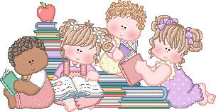 | March 13, 2020  Weekly Class News  From the second grade classroom of Mrs. Young

Our Week At A Glance…Is it Spring yet? Our literacy and writing blocks have been learning about reading and writing flyers. They are really “rocking” it! We tested on Unit 9, this week, I will send IPPs home tomorrow. Again, we will continue to practice on math facts with addition and subtraction. Four more days till Spring Break. I will be working on report cards this next week! I will go through the responsibilities with the kiddos!
Next Week’s Highlights  Monday – 3/16  Music  P.E.  Return Library books  Tuesday – 3/17  Library  Art  Wednesday – 3/18  Milwaukee Museum Field trip – bring a cold lunch  Thursday – 3/19  Library  Art  Guest Teacher  Friday – 3/20  Record’s Day  March 20-March 29th: Spring Break  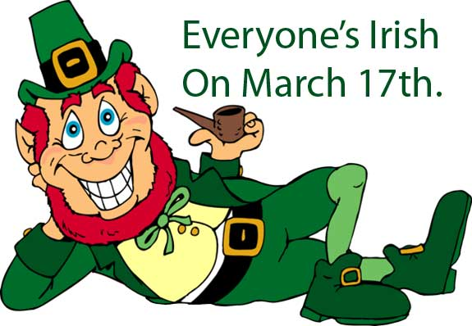 |  | More news…
Reading Tip… Say tongue twisters. Tongue twisters are a fun way to practice sounds. Let your child tell you the story. Many children memorize stories they've heard many times. Let your child take a turn "reading" the book to you.
Math Tip… Do not feel that you must use every number in a problem when doing your calculations. Some mathematics problems have "extra" information. These questions are testing your ability to recognize the needed information, as well as your mathematical skills.
Reminders:
- Spring Break next week – March 23-March 29, . Give them lots of hugs for me!

