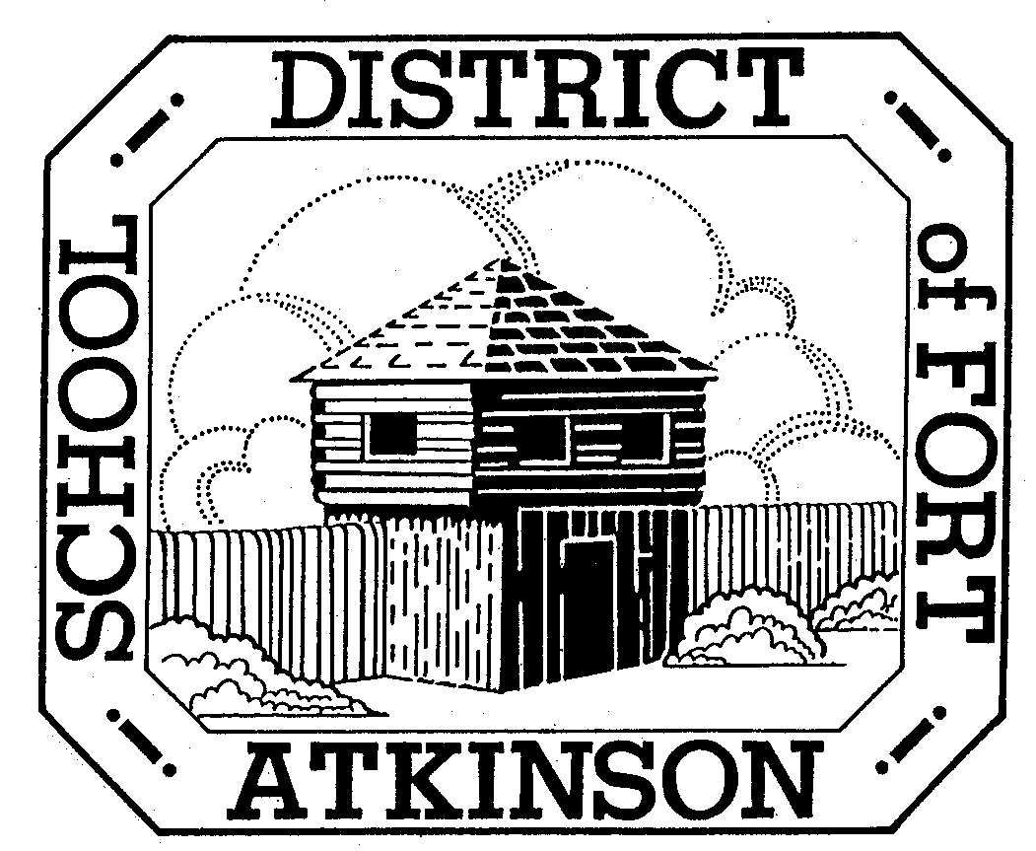
4 Year Old Kindergarten
School District of Fort Atkinson
201 Park Street, Fort Atkinson, WI 53538
920-563-7803, 920-568-4468; FAX 920-563-7809

What is 4 Year Old Kindergarten?
Four Year Old Kindergarten (4K) is a community-based program for 4 year old children residing within the School District of Fort Atkinson or open enrolling into the district.
- Children must be four years old by September 1. There are no early admissions
- Children are enrolled in the School District of Fort Atkinson’s 4K program but taught in a community-based preschool / daycare setting. Current community partners include Beautiful Beginnings, Fort Pre-School, Jefferson County Head Start, Kids Konnection, Parent’s Cooperative Preschool, St. Joseph’s, and Trinity Lutheran Church (TLC).
- The experientially-based programs are taught by highly qualified Wisconsin Department of Public Instruction licensed teachers.
- Classes run Monday through Thursday from 8:00- 11:10 AM or 11:50-3:00 PM on the same days that the K-12 schools are in session. At St. Joseph’s, classes will run Monday through Friday 8:00 – 10:30 AM or 12:30 – 3:00 PM.
- There is no tuition for parents to pay to have their child in the 4K program.
- Some locations offer optional extended child care. Parents are responsible for arranging and paying the costs for child care beyond the 4K hours.
- The program includes a strong focus on parent-school communication with regular family outreach workshops, activities and conferences.
What will my child learn?
Children will participate in experiential-based activities that provide rich learning opportunities. A focus on learning through play allows children to gain skills in all areas including: social-emotional, physical, cognitive, language development, early literacy and self-help. Teachers will use the Creative Curriculum which enhances those experiences through a hands-on approach. Children will learn many of the things that will lead to success in elementary school.
How can I enroll my child in 4K?
You can enroll your child into the 4K program by completing the registration sheet. You can download a copy of the registration sheet online at www.fortschools.org. You can also pick one up at the district office (201 Park Street), at one of our community partners’ locations or at any elementary school.

Frequently Asked Questions:

- Will 4K replace 5 year old kindergarten?

ANSWER: No. Four year old kindergarten has been proven to be beneficial to students and families as they transition to 5-year old kindergarten. Four year old activities are designed to support learning as children spend time in play. Experiential activities develop many skills and behaviors that provide a good foundation for success in school.

- Who is eligible for 4K?

ANSWER: Any child who turns 4 years old on or before September 1st and resides within the District’s boundaries is eligible to participate in 4K.

- Do parents have say in which location their child will attend?

ANSWER: Parents will be asked to complete a registration sheet and to list their top three preferences on where they want their child to attend. The School District of Fort Atkinson will make every effort possible to honor your first preference. If you do not receive your first preference, a representative from the district will contact you to discuss your options.

- If my child is sick, who would I call to report the absence?

ANSWER: You would contact the community partner (pre-school / daycare provider) where your child attends 4 year old kindergarten. In turn, a representative from the community partner will contact the district.

- Will busing be available for my child?

ANSWER: If you live outside of the city limits of Fort Atkinson, busing will be made available to your child. If you reside within the city limits and would like busing, you would have the opportunity to purchase this service from Double 3 bus company.

- When will school be in session?

ANSWER: The 4 year old kindergarten program will run Monday through Thursday on the same days that the K-12 schools are in session. The program will be a half day, and student can attend either in the morning (8:00 – 11:10 a.m.) or afternoon (11:50 – 3:00 p.m.). St. Joseph’s will run Monday through Friday from 8:00 – 10:30 a.m. or 12:30 – 3:00 p.m.

- Can my child open enroll into the 4K program if we reside in another district’s boundaries?

ANSWER: You can open enroll your child into the Fort Atkinson 4K program as long as your resident district also has a 4K program. The open enrollment application comes out in January and is due to the District Office no later than the 3rd Friday in February.

- Who will oversee the program?

ANSWER: An Elementary Principal will be the administrator of the program. There will also be a Program Coordinator to oversee day-to-day operations. These individuals will meet with the community partners on a regular basis to review the program and to ensure that the students’ needs are being met.

- If we move into the district after September 1st, can my child still sign up for 4K?

ANSWER: Yes. You would need to contact the School District of Fort Atkinson to go through the enrollment process.

